Identifying brief records.

Important: Do not edit MFHDs (holding records) associated with brief records. Instead, complete a transfer problem form and set the volume(s) aside.

There are two kinds of brief bibliographic records: Geac-merge and NOTIS unlinked items. They are in distinct ranges of Voyager BIB ID’s. The BIB ID appears in the title bar of the BIB record window (see example below).

In some cases both a brief and a full record may match a volume. Do not edit either one. Complete a transfer problem form and set the volume(s) aside.

I. Geac-merge records or “uuuu records” [from the Date 1 field], were loaded from our former Geac circulation system. All Geac-merge records are in the BIB ID range 1200000 – 1950000 (though most in this range are not brief). They all contain an 035 field beginning (CStRLIN)RLINGEAC. The 008 display contains 6 digits plus
s uuuu ____ ___ ____ _ _ ____ _ 0 0 0 0 0 _ ___ _ d.

BIB ID
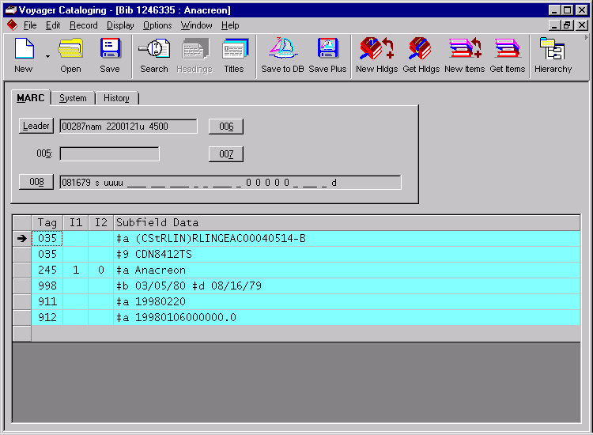
008
035

Dates in titles index displays are uuuu.

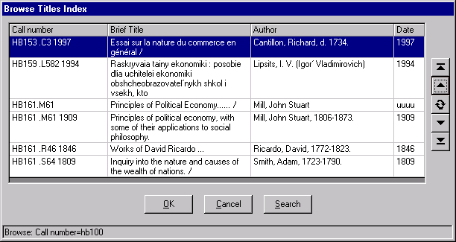

II. NOTIS unlinked item records. These records are in the BIB ID range 3180555 – 3200356. Any record in this BIB ID range is brief. The 035 begins with two letters. The 008 field consists of 6 digits plus vertical lines.

BIB ID

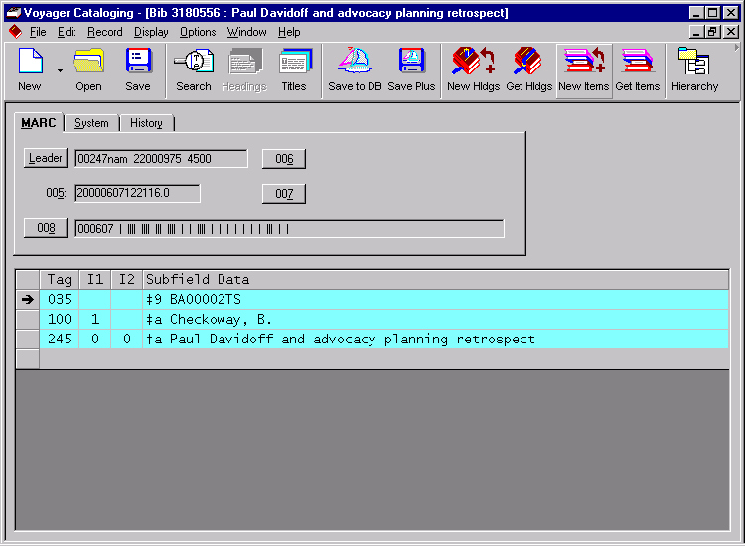

008

035
Dates in titles index displays are ||||.

